# File permissions in Linux

## Project description

The Linux commands in this project show the files and directories in a folder, including hidden files and their permissions. The Linux commands in this project change the permissions of files or the directories.

## Check file and directory details

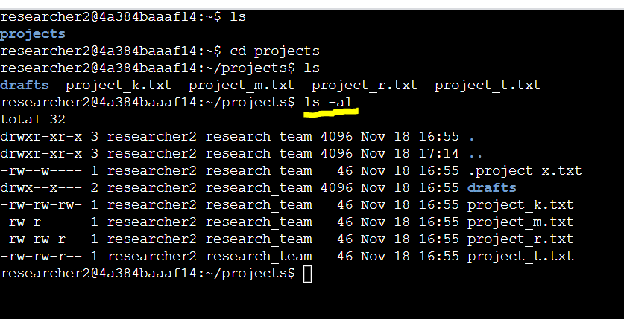In Linux, the command “ls” shows all the files in a directory.

The Linux command “ls -a” shows all the files in a directory including the hidden files.

The command “ls -l” shows all the files in directory and its permissions.

The Linux command “ls -al” shows all the files in a directory including the hidden files and the permissions.

## Describe the permissions string

The file permissions of the project_k.txt is shown as string of characters from the screenshot is as -rw-rw-rw-. The breakdown of the string of characters is divided by the user, the group, and others users and their ability to read, write and execute the file. The first character in the sequence is “-” and depicts that the item is a file rather than a “D” meaning the item is another directory. The 2nd 3rd and 4th characters in the sequence, “r”, “w”, and “-”, is representative of the permissions for the user for the file. This shows that the user can read, write, and NOT execute the file. The 5th, 6th, and 7th characters are representative of the permissions of the group for the file. The group has the same permissions as the user for this file. Finally the 8th, 9th and 10th characters in the sequence are representative of the other users permissions. The other permissions are the same read, write and NO execute as the group and user permissions.

## Change file permissions

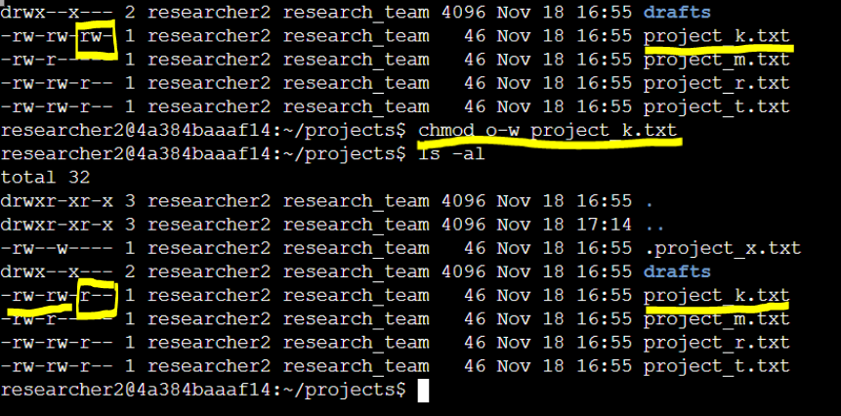

The organization does not allow others to write in any files. We see that originally the “project_k.txt” file allowed others to write, so we needed to edit the permissions of the file using the “chmod o-w project_k.txt”. The breakdown of the Linux command “chmod o-w project_k.txt” used in this scenario is that the “chmod” command changes the permissions of the file. The “chmod” command requires two arguments: the first indicates how to change the permissions, and the second the file or directory you want to change. So in the command the “o-w” translates to take away others’ permissions to write for this file. The last part “project_k.txt” is the 2nd argument of the chmod command, in which file changes in permissions are applied to.

## Change file permissions on a hidden file

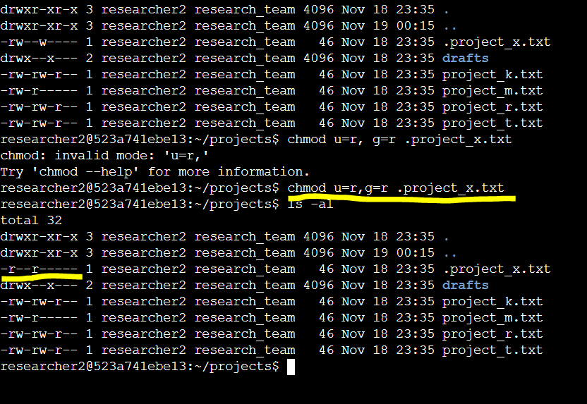

The research team has archived **.project_x.txt**, which is why it’s a hidden file. This file should not have write permissions for anyone, but the user and group should be able to read the file.

In a previous Linux command of “ls-al”, it showed all the files including the hidden .project_x.txt file and its permissions. The file should not have a write permissions for anyone, but the screenshot shows that both the user and the group still have access to write in the file shown in the permissions string

‘-rw-w----’. Using the Linux command “chmod u=r,g=r .project_x.txt”, I’m able to change the permissions of the hidden file, “.project_x.txt” to where it needs to be set. Breaking down of the command, “chmod” changes permissions of a file or directory. The first argument in the chmod command, “u=r,g=r” is first setting the user permissions to only be able to read the file then after the comma sets the group’s permissions to only be able to read the file. The second argument for the chmod command, “.project_x.txt” (including the period in front of the file name) is for which file the permission changes will occur. We can check to see if the changes that we made went through by again putting in the Linux command “ls-al”. From the screenshot after the permissions change command, we see the permission string of the “.project_x.txt file” now reads

‘-r--r-----’ showing that the permissions command was successful.

## Change directory permissions

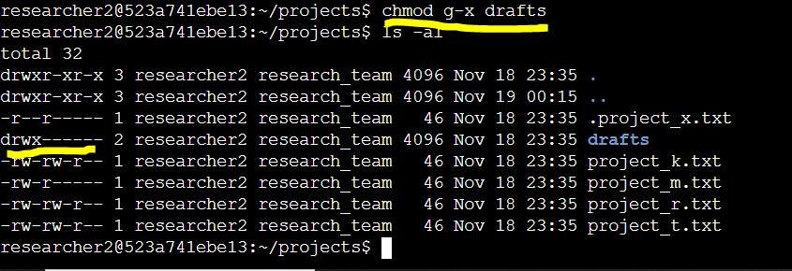

In the previous screenshots of the process, we see that the “drafts” directory’s permission string reads ‘drwx--x---’ meaning that the user has all permissions but the group is able to execute in the directory. The starting ‘d’ in the permissions string shows that this is a directory instead of a ‘-’ meaning it is a string. Only the user researcher2 should be allowed to access the drafts directory and its contents. Using the Linux command, “chmod g-x drafts”, I can edit the ‘drafts’ directory to remove the execute permissions from the group. Using the “ls -al” Linux command shows the updated permission string of the drafts directory, ‘drwx------’, showing that using the changing permissions command was executed successfully.

## Summary

Using the Linux command “ls -al”, we are able to see all files and directories, including hidden, and their permissions in a folder. The read, write and execute permissions for the user, group and other users are depicted in the file’s permission string “drwxrwxrwx” Using the Linux command “chmod” we are able to add or remove certain permissions in a file or directory to fulfill the needs of the security team and the company.